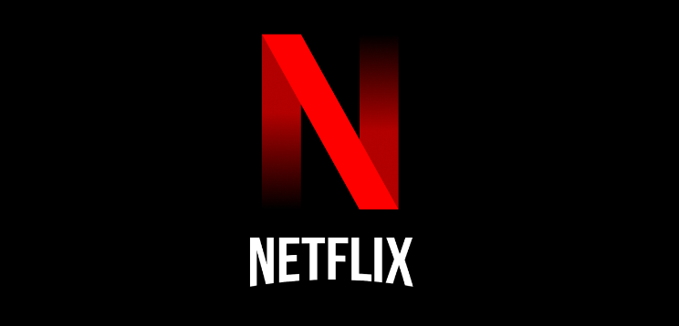

**Product Dissection for Netflix**

### **Company Overview:**

Netflix is a global streaming entertainment service founded in 1997 by Reed Hastings and Marc Randolph. Initially offering DVD rentals by mail, it transitioned to a subscription-based streaming platform in 2007. As of 2022, Netflix boasts over 200 million subscribers in over 190 countries, offering a vast library of TV shows, movies, documentaries, and original content. The company invests heavily in original programming, producing award-winning series and films such as "Stranger Things," "The Crown," and "Bird Box." Netflix's innovative approach to content delivery and its focus on personalized recommendations have solidified its position as a dominant force in the entertainment industry.

### **Product Dissection and Real-World Problems Solved by Netflix:**

Netflix's success can be attributed to both its vast collection of entertaining material and its creative problem-solving and product development methodologies. This is an analysis of Netflix's features and the practical issues it has successfully resolved in the real world:

Netflix's unwavering commitment to global content accessibility, iterative quality improvement, and relentless pursuit of quality have completely transformed the entertainment industry. Netflix is fundamentally concerned with the quality of the content it offers, regularly releasing both licenced and original content of the highest caliber. Users who expect nothing less than the best from the platform develop a sense of entitlement as a result of this commitment to quality, which guarantees subscribers an unmatched viewing experience.

Furthermore, Netflix's focus on ongoing development spurs innovation in user experience, technology infrastructure, and content delivery. Netflix constantly improves its algorithms and user interfaces, optimizing content recommendation and discovery systems to better suit the varied tastes of its audience. This is achieved through data-driven insights and user feedback. This iterative process not only improves user satisfaction but also solidifies Netflix's leadership in the streaming entertainment sector.

Netflix's dedication to content accessibility is among its greatest contributions. With a huge selection of films in many languages, genres, and cultural contexts, Netflix makes sure that entertainment is inclusive and available to a wide audience. In addition to enhancing cross-cultural dialogue, this democratization of content tackles pressing issues with diversity and representation in the media.

Also by breaking down barriers based on geography and culture, Netflix has been able to reach viewers in over 190 countries thanks to its aggressive global expansion strategy. This broad reach not only increases Netflix's impact but also promotes global economic expansion and cross-cultural interaction. With its steadfast commitment to quality, ongoing development, content accessibility, and international growth, Netflix is redefining the entertainment industry while addressing pressing issues and influencing the direction of streaming media.

### **Case Study: Real-World Problems and Netflix Innovative Solutions**

**Problem 1 :** **Limited Content Availability and Fragmentation**

**Real-World Challenge :** Due to the fragmented content offered by traditional TV networks and cable providers, viewers had to subscribe to multiple services in order to watch their favorite shows and movies, which was inconvenient and expensive.

**Netflix's Innovative Solution**: By consolidating a sizable content library onto a single platform, Netflix offers its subscribers a convenient and all-encompassing entertainment option. Netflix made watching easier and less fragmented by doing away with the need for multiple subscriptions by providing a wide variety of licensed and original content across genres.

**Problem 2: Outdated Distribution Models**

**Real-World Challenge :** Traditional distribution models relied heavily on physical media and scheduled broadcasts, limiting audience access to content and constraining the reach of creators and distributors

**Netflix's Innovative Solution**: Netflix pioneered the concept of streaming media, introducing an on-demand distribution model that allowed viewers to access content anytime, anywhere, and on any device with an internet connection. By leveraging digital technology and cloud-based infrastructure, Netflix revolutionized content delivery, offering unprecedented flexibility and convenience to consumers while expanding the global reach of content creators.

**Problem 3: Advertiser Influence on Content**

**Real-World Challenge :** Traditional television networks often prioritized advertiser interests over creative integrity, leading to the proliferation of interruptive and intrusive advertising that detracted from the viewer experience.

**Netflix's Innovative Solution**: Netflix adopted a subscription-based revenue model that eliminated the need for advertising, freeing content creators from commercial pressures and allowing them to focus on storytelling without compromise. By prioritizing subscriber satisfaction over advertiser demands, Netflix preserved the integrity of its content and differentiated itself as a premium entertainment platform dedicated to delivering ad-free viewing experiences.

**Problem 4: Lack of Personalization and Recommendation**

**Real-World Challenge :** Traditional TV programming offered limited options for personalized content recommendations, relying on broad demographics rather than individual preferences to curate viewing experiences.

**Netflix's Innovative Solution**: Netflix implemented sophisticated algorithms and machine learning techniques to analyze user data and behavior, enabling highly personalized content recommendations tailored to each subscriber's unique tastes and interests. By leveraging data analytics and predictive modeling, Netflix enhanced user engagement and satisfaction, driving increased viewership and retention.

**Conclusion:**

Netflix has demonstrated a remarkable ability to identify and address real-world problems in the entertainment industry through innovative solutions that prioritize consumer convenience, creative freedom, and personalized experiences. By challenging traditional norms and embracing digital disruption, Netflix has not only transformed the way people consume entertainment but also reshaped the entire media landscape. As Netflix continues to evolve and innovate, it remains at the forefront of shaping the future of entertainment, inspiring industry-wide change and revolutionizing the way stories are told and experienced.

### **Top Features of Instagram:**

1. **Vast Content Library**: Netflix provides a vast and diverse library of movies, TV shows, documentaries, and original content, catering to a wide range of tastes and preferences.
2. **Original Content**: Netflix produces high-quality original series, films, and documentaries known as "Netflix Originals," which are exclusive to the platform. These original productions have garnered critical acclaim and contributed to Netflix's reputation as a leading content creator.
3. **Personalized Recommendations**: Netflix utilizes sophisticated algorithms to analyze user viewing history, preferences, and ratings to offer personalized content recommendations. This feature enhances the user experience by suggesting relevant titles tailored to individual tastes.
4. **Multiple Profiles**: Netflix allows users to create multiple profiles within a single account, enabling personalized viewing experiences for each household member. Each profile maintains separate viewing histories, recommendations, and watchlists.
5. **Ad-Free Experience**: Unlike traditional television, Netflix is ad-free, providing uninterrupted viewing experiences without commercial breaks or advertising interruptions.
6. **Parental Controls**: Netflix offers parental control features that allow parents to restrict access to content based on maturity ratings. Parents can set PIN codes to prevent children from accessing inappropriate content.
7. **Cross-Platform Compatibility**: Netflix is available on a wide range of devices, including smartphones, tablets, smart TVs, gaming consoles, and streaming media players. Users can access Netflix across multiple devices, providing flexibility and convenience.
8. **Multiple Language and Subtitle Options**: Netflix offers content in multiple languages and provides subtitle options for many titles, making it accessible to a global audience and catering to viewers with diverse language preferences.

### **Schema Description:**

The schema for Netflix involves multiple entities that represent different aspects of the platform. These entities include Users, Subscription Plan, Content, User Content , Review, Genre, Director, and Content Director. Each entity has specific attributes that describe its properties and relationships with other entities.

**User Table:**

Stores information about users including their unique ID, username, email, and password, as well as their subscription plan.

* **UserID (Primary-Key):** Unique identifier for each user.
* **Username:** Name chosen by the user for identification.
* **Email:** Email address associated with the user's account.
* **Password:** Encrypted password for user authentication.
* **SubscriptionPlanID (Foreign-Key):** References the subscription plan chosen by the user.

**Subscription Plan Table:**

Contains details about the subscription plans offered by Netflix such as plan name, price, and features.

* **SubscriptionPlanID (Primary-Key)**: Unique identifier for each subscription plan.
* **PlanName**: Name of the subscription plan.
* **Price**: Cost of the subscription plan.
* **Features**: Description of features included in the subscription plan.

**Content Table:**

Holds data related to the available content on Netflix including titles, descriptions, genres, release dates, durations, and languages.

* **ContentID (Primary-Key)**: Unique identifier for each piece of content.
* **Title**: Title of the content.
* **Description**: Brief overview of the content.
* **Genre**: Category or genre of the content.
* **ReleaseDate**: Date when the content was released.
* **Duration**: Length of the content.
* **Language**: Language in which the content is available.

**User Content Table:**

Represents the relationship between users and the content they have watched, storing the watched date alongside user and content IDs.

* **UserID (Foreign-Key)**: References the user who watched the content.
* **ContentID (Foreign-Key)**: References the content that was watched.
* **WatchedDate**: Date when the content was watched by the user.

**Review Table:**

Stores user reviews for content, including ratings, comments, and timestamps, associated with specific users and content.

* **ReviewID (Primary-Key)**: Unique identifier for each review.
* **UserID (Foreign-Key)**: References the user who provided the review.
* **ContentID (Foreign-Key)**: References the content being reviewed.
* **Rating**: Numerical rating given by the user for the content.
* **Comment**: Textual comment provided by the user for the content.
* **Timestamp**: Date and time when the review was submitted.

**Genre Table:**

Lists different genres available for content categorization, with each genre having a unique ID and name.

* **GenreID (Primary-Key)**: Unique identifier for each genre.
* **GenreName**: Name of the genre.

**Director Table:**

Contains information about directors involved in creating content, identified by a unique director ID and their name.

* **DirectorID (Primary-Key)**: Unique identifier for each director.
* **DirectorName**: Name of the director.

**Content Director Table:**

Establishes a many-to-many relationship between content and directors, indicating which directors are associated with specific content titles.

* **ContentID (Foreign-Key)**: References the content associated with a director.
* **DirectorID (Foreign-Key)**: References the director associated with the content.

**Relationships are:**

**User Table and SubscriptionPlan Table:**

* One-to-many relationship.
* Each user can have only one subscription plan, but a subscription plan can be associated with multiple users.

**User Table and UserContent Table**

* One-to-many relationship.
* Each user can have multiple records in the UserContent table, representing the content they've watched, but each record corresponds to only one user.

**Content Table and UserContent Table:**

* One-to-many relationship.
* Each piece of content can have multiple records in the UserContent table, indicating multiple users who have watched it, but each record corresponds to only one piece of content.

**Content Table and Review Table:**

* One-to-many relationship.
* Each piece of content can have multiple reviews associated with it, but each review corresponds to only one piece of content.

**User Table and Review Table:**

* One-to-many relationship.
* Each user can provide multiple reviews, but each review corresponds to only one user.

**Content Table and Genre Table:**

* Many-to-many relationship.
* A piece of content can belong to multiple genres, and a genre can be associated with multiple pieces of content. This relationship is implemented through a junction table, but it's not explicitly shown in the schema provided.

**Content Table and ContentDirector Table:**

* Many-to-many relationship.
* A piece of content can have multiple directors, and a director can be associated with multiple pieces of content. This relationship is implemented through a junction table, but it's not explicitly shown in the schema provided.

### **ER Diagram:**

Let's construct an ER diagram that vividly portrays the relationships and attributes of the entities within the Netflix schema. This ER diagram will serve as a visual representation, shedding light on the pivotal components of Netflix’s data model. By employing this diagram, you'll gain a clearer grasp of the intricate interactions and connections that define the platform's dynamics.

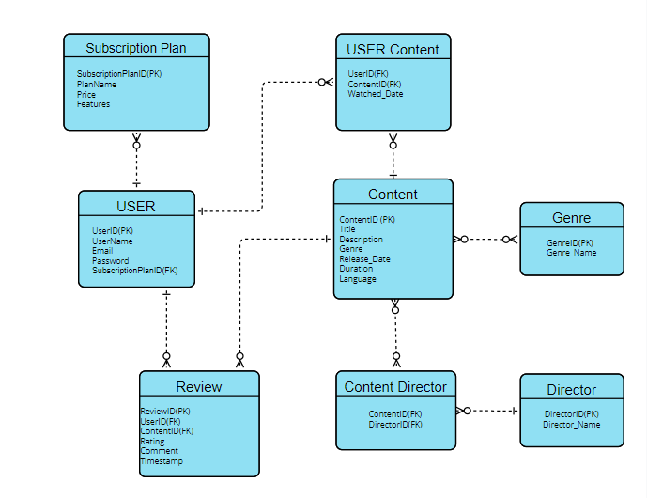

### 

### **Conclusion:**

In dissecting Netflix, it becomes evident that its success lies in its ability to intertwine technological innovation with compelling content delivery. Through its user-centric approach, Netflix has reshaped the entertainment landscape, offering a vast array of content tailored to individual preferences. The subscription-based model, coupled with personalized recommendations and seamless streaming experiences, has cultivated a loyal global audience. Its original productions have further solidified its position as an industry leader, setting new standards for quality and diversity in storytelling. By continuously adapting to evolving consumer trends and investing in cutting-edge technologies, Netflix has not only revolutionized how we consume media but has also redefined the paradigm of entertainment in the digital age.